 Translated from Malay to English - www.onlinedoctranslator.com
JPN.KC02


NATIONAL REGISTRATION DEPARTMENT OF MALAYSIA

APPLICATION FORM, MARRIAGE NOTICEANDSTATUTORY/WRITTEN STATEMENT
Law Reform (Marriage and Divorce) Act1976
/Section 14, 16,2I(I},22(3, 26]
FOR OFFICE USE
Registration Authority Code/CodeRegistrar No. Application
Date of Application
Date of Marriage
TYPE OF APPLICATION
[ ]-01 Notice of Marriage and Written Declaration
( ]-02 Application to Celebrate Marriage According to Religious Ceremony, Custom or Custom[ ]-03Application For A Marriage License Without Requiring Marriage Notification
and Certificate for Marriage
[]-04 Notification of Marriage and Written Declaration for Marriage overseas
LICENSE TYPES INCLUDED
[ ]-01 FORM JPN.KC01A []-02 Form JPN.KC0lb [ ]-03 Form JPN.KC01C []-04 FORM JPN, KC01D []-05Form JPN.ltC01E
INSTRUCTIONS
- Please fill out this form withusing BLACK/BLUE ink.
- Please use "UPPERCASE LETTERS".
- Please mark tick (/) on the marked boxes(*).
- Cut any that do not apply to those marked (• •).
- Sections A, B and C are filled in by the applicant.

Arrangements for applicants
- A person applying to get married must have lived in a marriage district for less than SEVEN DAYS (MarriageatNational Registration Department only).
- If both parties to the marriage stayAT THE SAME WEDDING DISTRICT shouldfill in and sign this form in front of the Register of Marriages at the area.
- If both parties get married, stay at different district they have to fill in and sign this form in front of the Registrar of Marriages in the relevant marriage district where they live.
- AGE MINIMUM FOR MAN AND FEMALE IS 18 YEARS OLD, Female aged even 16 year but at below 18 guesses can also get married with the condition of first obtaining a license from the Chief Minister.
- Someone who has not completed age 21 year is required,before marriage, obtain written consent:
(n) from his father; uncle
- if the person is legitimate and his father is dead, from his mother and
- if the child is an adopted child, from his adoptive father, and if his adopted father is married, from his adopted mother; or
- if both parents (real parents and Foster parents) is dead,from people where becomes guardian that takes before they reached that age; or
- from court
- A certificate must be made at before a Magistrate or Commissioner of Oaths by both spouses.
- Applications that do not require a marriage notification or marriage certificate need to obtain a license.

1. Number 1 to5 used for marriage applications managed by the National Registration Department and Malaysian representatives abroad.
- Reminder 4,5 and 6 is used for hospitality marriage arranged by Church/Temple/Association olet.
- Reminder 4,5,6 and7 used for marriage applications managed by the National Registration Department and Malaysian Representation at overseas for marriage without the need for notification of marriage and certificate for marriage.
To the Registrar/Assistant Registrar of wedding at ..........................,................ ................................................ ..................
We/I request/inform regarding the proposed marriage between us/me as described in this form.

PERSONAL INFORMATION OF MEN
1 . No, Code Introduction (IC NUMBER)

- No. Other Identification Documents

- Other Types of Identification Documents

- Country Document Producer

Name

Photo

(32nıın x 3gnın›)

- Father's name

- Address


- Postal code 9. City

10.state il. No. Telephone

l2. Date of birth

Day Month year
- Citizen

- Domicile Country

15.Religion *
Islam, Christianity, Buddhism, Hinduism NoneReligion Other religion (say it )

- Jobs

- Married situation. No. Death Certificate/No. Divorce *Not yet * Marriage *Widower
19. Date registration of death/Divorce Certification**. Place of Registration of death certificate/Divorce Certificate **

Day Month Year
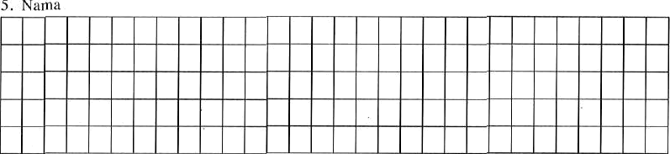
2

PERSONAL INFORMATION OF WOMEN
21. No. Identification card (IC NUMBER)

- No. Other Identification Documents

- Other Types of Identification Documents

- Negarn Producer of Dokuınen

Female Gsmbar (32mm x 38mm)

- FATHER’S NAME

- Address
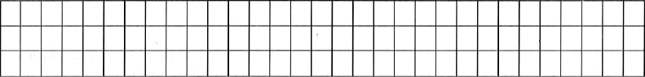
28,Postal code 29. City
30.state 31.No.Telephone

- Date of Birth

Day Month Year
- Citizens 34. Country of Domicile

- Religion*
lSLAM CHRISTIAN Buddha Hindu No Religion Different Religion (Specify)

- Jobs

- Married Situation * 38. No. Death Certificate/No. Divorce Certificate**
*Not yet *Married *Widower

39. "Date Register of Death Certificate/Divorce Certificate".*• 40. Place of death certificate /Certificate of Divorce*•

Day Month Year
PROPOSED PLACE OF CEREMONY
41 . Area of Marriage

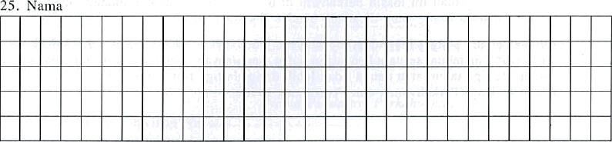
3

** DECLARATION FOR MARRIAGE AT THE NATIONAL REGISTRATION DEPARTMENT or EMBASSY MALAYSIA OUTSIDE COUNTRY 1
We/ I ** truly acknowledge that
- We/I** stay in the district of the marriage around seven day before the notification was given;
- (i)We/I* male/female side**is 21 years of age and older;

  - WE/I ** is male/female**is aged under 21 year and a widower**;or
  - WE/I** male/female side**is bemmur in down 21 year and not yet married;
and
the consent of those concerned for marriage male/female **sorting section 12 given written and attached together this/ not required**.
- The female party is not under the age of 16;
- There is no resistance which valid against this marriage; and
- None of the parties to marriage this still get married below something law,religion, customs and the prevalence with someone other than the person proposed to be married.
All details given in this form to the best of our/my knowledge and belief**is true and we/I**understand that if in this application we/I** make false statements, we/I**may, upon conviction, be sentenced to imprisonment for a term of not more than three years and a fine of not more than three thousand ringgit or both under section 28, Law Reform (Marriage and Divorce) Act, 1976.

SignatureMen Women's sign

I hereby confirm that
**(a) Confession at above is translated listen according to at front by me
(NAME OF TRANSLATOR)
to which make confession in this language which is understood by those who make this action.
**(b)The above is not required.

................................................ .. . ................................................ ........
Signature Interpreter Name NAME and the signature of the Registrar of Marriages and Royal Seal

..
.............................................. ......................
Date Date
**STATUTORY DECLARATION FOR MARRIAGE IN CHURCH/TEMPLE/ASSOCIATION and LICENSE UNDER SECTION 21t1)
We/I** by really acknowledge that
- (i) We/I•*men/women who are 21 years old and older;aran
  - WE/I*• the male/female side is under the age 21 year of being a widower/widow**; OR
  - We/I*•the male and female sides are differentation down 21 years that's it and not yet get married;and
the consent of the person concerned for the marriage parties male/female according to section l2 was given in writing and attached here with/ not needed.
- The women is not aged below 16 year;
- There is no legal objection to this marriage; and
- None of the parties to marriage this still get married below something law,religion, customs and the prevalence with someone other than the person proposed to be married.

We/I**make this statement in the belief that anything stated in this Form is true and correct the provisions of the 1960 Statutory Act.
Made and with real acknowlegement by the name said above,
that is(1) (1)
that is(2) Male’s signature
at in the country
on date ,
Female sign
In Front of me,

. ........ . .. .....................................
Signature of Magistrate/Commissioner of Oaths** den Official Stamp

VERIFICATION OF NOTIFICATION RELEASE BY NATIONAL REGISTRATION DEPARTMENT
(FOR THE CEREMONY AT THE EMBASSY)
I am confirm that the Marriage Notice has been
(NAME OF REGISTOR OF MARRIAGE)
posted at the Registrar's Office of my marriage district for no less than 21 days until any complaints or objections have been received.

.........................................-..- . .....................--------- .
Date REGISTOR 's signature Marriage
dnn Official Stamp

Marriage District: ..,.............................,.,......,... ...................
State:
CERTIFICATE FOR MARRIAGE (BY EMBASSY)
I, have released
(N‹im‹i Pendafiar Perkwitiun}
Marriage certificateNo. after satisfied that
- one or both parties to the marriage are Malaysian citizens;
- each party is capable of marrying in accordance with this Act;
- if one of the parties is not domiciled in Malaysia, the proposed marriage, if solemnized. Will considered as valid in the country in where is domiciled.
- Notification of the proposed marriage has been given at least 21 days and no more than 3 months and is notification has been alerted at this Office and Marriage District Registrar's Office at and Malaysia and no complaints or objections have been received.

......................... ......................................................
Date Signature of Registrar Marriage Embassy/
Malaysian High Commission/Consul**and Official Stamp
CONFIRMATION OF MARRIAGE
42.No.Payment receipt Register 43. Date of issue

Day month Year
- Total Registration Fee
RM
- No. Certificate For Marriage 45A. No. Payment receipt Certificate 45B,Total Payment of Certificate
RM

RM

46, Marriage Registrar Code 47. No. Identification card

48 Name
49. DateCeremony50. No. Registar of Marriage
Day month year
I am Acknowledging that the marriage between the said parties has been solemnized,

. ................................................ ......................
ArrivalMarriage Registrar/Assistant Marriage Registrar** and Official Stamp

3O105883--PNMB.. KL

